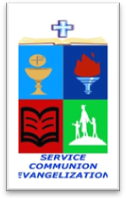
ROMAN CATHOLIC BISHOP OF NOVALICHES
EDUCATIONAL SYSTEM (RCBN-ES, INC.)
Corner P. dela Cruz, Quirino Highway, Quezon City

CLE Pointers for review

CLE 6

Lesson 11-The Church is One p.116-127
Lesson 12 – The Church is Holy p. 128 – 137
Lesson 13 – the Church is Catholic p. 138-147
Lesson 14 – The Church is Apostolic p. 148-159
Lesson 15 – The Essential Characteristics: Gifts and Task 160-169

Note: Please bring crayon

